INSTRUCTIONS FOR PREPARATION OF FULL TEXT PAPERS

FOR THE CONFERENCE PROCEEDINGS (TITLE MAX 2 LINES)

Authors: Gianfranco BRONZINI1, Tino RIZZI2

Affiliation: 1 Conzett Bronzini Partner, structural engineers, Chur, Switzerland

Contact: g.bronzini@cbp.ch

**Summary** (maximum 15 lines)

These instructions have been prepared for submitting the full papers (max 8 pages) to the conference. Please use this format only for the full paper. A different template has to be employed for one-page abstract. All templates can be downloaded from the webpage <https://footbridge2025.com/abstracts-papers>. The summary should consist of one paragraph giving the objectives of the paper, a brief summary of the work presented in the following sections and a general conclusion. Please limit the summary to 15 lines.

**Keywords:** Include a concise list of not more than ten keywords, for example: historical; aesthetics; dynamics; structural concepts; planning; new materials; lateral vibration; response; damping.

# Introduction

Guidelines for the preparation and submission of full text papers (max 8 pages) are given in this document. All text, figures and tables should be placed within an area 170 mm wide and 252 mm high. On A4 paper, this is equivalent to left- and right-hand margins of 20 mm, top margin of 36 mm (52 mm on the first page) and bottom margin of 20 mm. The page numbering will be added later on by the publisher.

Although manuscripts and designs will be peer-reviewed and may be returned to authors for revisions before publication, initial submissions should be made in final form assuming that no revisions shall be necessary.

Delay in returning papers and failures of the authors to meet specific deadlines may cause the papers to be excluded from publication. Re-submitted papers that do not meet the conference requirements may be rejected.

# General formatting requirements for full text papers

## First Page

The first half of the page should include the title, information on the author(s) and the summary. The title (Arial Regular, bold 14, capital letters, left-aligned) in English must not exceed more than two (2) lines. Data for each author should include; 1) given name and FAMILY NAME; 2) Title or Position; 3) Company; 4) City and Country; 5) Email address. A maximum of ten keywords (Arial Regular 10) should be given after the summary, with an overhanging indent of 20mm. The paper, in English, should begin on the lower half of the first page.

## Fonts and format to be used

### Body Text

Body text should be written in Arial Regular 10 pt, line spacing 12 pt. There should be no hyphenation (cutting words) and the text should be justified. Authors are encouraged to use pure English letters. Diacritics usage may lead to printing mistakes. The distance to the next body text segment should be 6 pt and the distance to the previous text body should be 0 pt.

### Headings

Headings should be limited to three levels and numbered appropriately using the decimal system. Main headings (1 Introduction) and subheadings should be written in Arial Regular bold 10 pt, line spacing 12 pt. Third level headings should also be written in Arial Regular italic 10 pt, line spacing 12 pt. The distance of the headings to the next text segment should be 6 pt and the distance to the previous text segment should be 12 pt.

### Captions and Lettering in Figures and Tables

The captions of figures and tables should be written in Arial Regular italic 10 pt, line spacing 12 pt. Lettering used in figures and tables should be large enough to be readable at reduced size (80%), i.e. characters should not be smaller than Arial 9 pt.

## Figures (Drawings and Photographs) and Tables



Fig. 1. This is a figure or table caption, italic

Careful attention should be given to the quality of images, drawings and pictures. The full text paper may contain elements in colour and active hyperlinks. For ease of file transfer use compact formats for images. The above images have satisfactory resolution in jpeg format (137 kB).

Create graphs and line drawings electronically, and insert them electronically into the finished document. Photographs should also be inserted into the document. All figures and tables must be inserted near the location where they are first described. Provide a Fig. number and caption below each figure or photograph and a Table followed by a number and caption above each table. The resolution should be 150x150 dpi (dots per inch) for photographs and 300x300 dpi for drawings.

|  |  |  |
| --- | --- | --- |
| **Yield Line** | **Number Normal BM**  **(Nmm)** | **Yield Line Length**  **(mm)** |
| **1** | -13.793 | 5.771 |
| **2** | -25.058 | 11.660 |
| **3** | -18.315 | 11.832 |
| **4** | -10.334 | 11.813 |
| **5** | -4.335 | 11.638 |

Table 3. Results for Axial Load

Tables should have borders for top and bottom and under headings, but no vertical borders. Scanned drawings and tables inserted as bitmaps are not acceptable.

It is the authors’ responsibility to obtain copyright permissions for reproducing any materials such as fi gures, tables or photographs. The conference organizers will not take any liability for authors’ failure to gain proper permission.

## Equations

Insert all equations using the equation editor (integrated in Microsoft Word), as text if possible, or as an image.

Equations should be referenced with a number shown in brackets, ( ), to the right of each equation:

 (1)

## Footnotes

Footnotes should not be used.

## Units

Use SI units exclusively. Decimal location should be indicated by a point “.” and not by a comma “,”.

## Discussion and Conclusions

The paper should finish with a discussion, final comments and conclusions.

## Acknowledgements

Acknowledgements of funding etc. should be placed in this separate section of the text.

## References

References should be listed in the order in which they appear in the paper and provided with a reference number in square brackets [1] using an overhanging indentation of 10 mm. References should be made in the paper using the appropriate reference number in square brackets. In the list of references, the authors’ names are uppercase and are followed by the initials. The titles of books, journals and proceedings should be in italics. Titles should be in lower and upper case as shown below. The year of publication and the page number(s) should be given.

[1] ANDERHEGGEN E., DESPOT Z., STEFFEN P., and TABATABAI S.R.M., “Reinforced Concrete Dimensioning based on Element Nodal Forces”, ASCE Journal of Structural Engineering, Vol. 120, No. 6, 1994, pp. 1718-1731.

[2] NIELSEN M. P., Limit Analysis and Concrete Plasticity, Prentice Hall, New York, 1984, 360 pp.

# Submission

Full text papers and their one-page abstract, both as word and pdf files, should be uploaded as a single .zip file using the Easychair online system at <https://easychair.org/conferences/?conf=fbc25>. In summary, the uploaded .zip file must include 4 files.

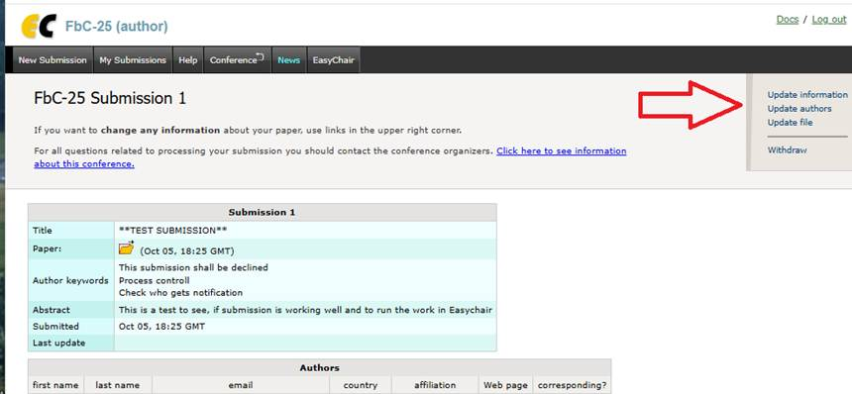

Fig. 1. Submission via easychair

Finally, we strongly encourage authors to sign up for the Footbridge2025 newsletter at <https://footbridge2025.com/>